EEE-6512 Image Processing and Computer Version

Homework #4

Wenxuan Wang

UF gatorlink username: wenxuanwang

Ufmail: wenxuanwang@ufl.edu

UFID:64118211

[1]

Coding Part

Run time

|  |  |  |  |
| --- | --- | --- | --- |
| **Method Filter** | **Run time when Filt size (k) = 3** | **Run time when k = 203** | **Run time when k = 403** |
| *mySpatialFilt*  Gaussian kxk kernel* | 12.714062 (seconds) | 754.786195 (seconds) | 19376.965323 (seconds) |
| *mySpatialFilt*  Gaussian kernel in separable form (1xk, kx1) | 9.926630 + 9.423075 = 19.349704(seconds) | 17.254265 + 15.397564 = 32.651829 (seconds) | 22.225345 + 22.251857 = 44.477202 (seconds) |
| *myFrequencyFilt*  Gaussian kxk kernel | 2.123148 (seconds) | 2.250671 (seconds) | 2.070121 (seconds) |
| *myFrequencyFilt*  Gaussian kernel in separable form (1xk, kx1) | 2.009496 + 1.945338  = 3.954834 (seconds) | 2.201564 + 1.892962 = 4.094526 (seconds) | 2.204099 + 1.829773 = 4.033872 (seconds) |
| MATLAB toolbox method for median filtering Median kxk filter | 0.002566 (seconds) | 3.143152 (seconds) | 7.666611 (seconds) |

*mySpatialFilt*, Gaussian 11x11 kernel

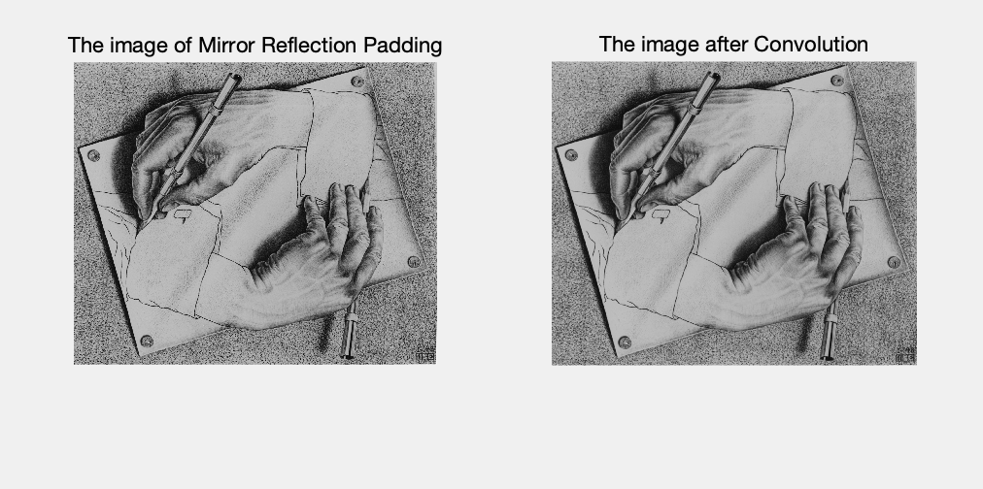

Figure 1. mySpatialFilt with Gaussian 11x11 kernel

*mySpatialFilt*, Gaussian kernel in separable form (1x11, 11x1)

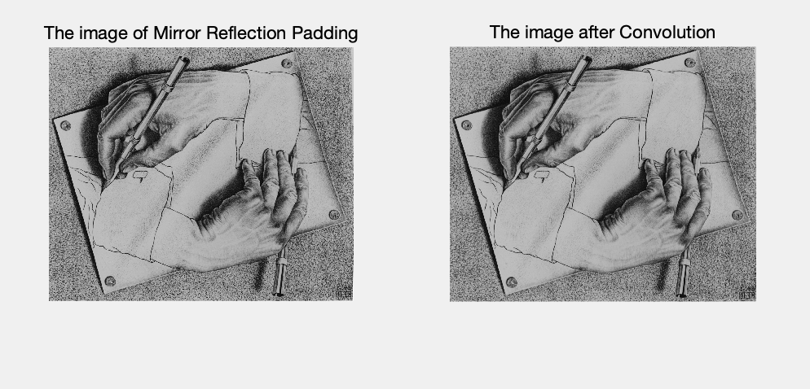

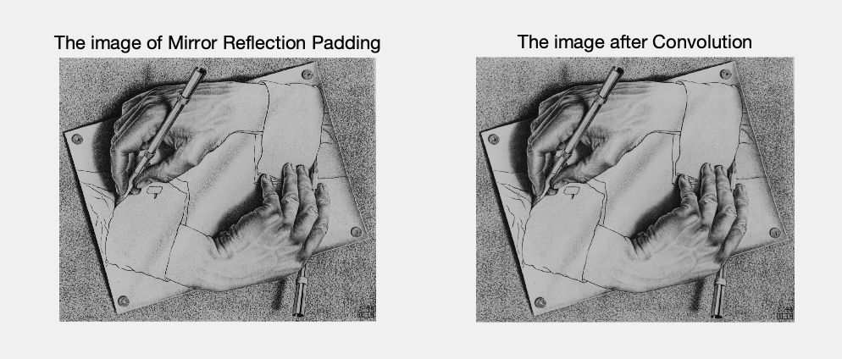

Figure 2.  mySpatialFilt with Gaussian kernel in separable form 11*1, 1*11)

*myFrequencyFilt*, Gaussian 11x11 kernel include the DFT of the image before filtering as well

Figure 3. myFrequencyFilt with Gaussian 11x11 kernel

The magnitude and phase of the image is before the filtering.

*myFrequencyFilt*, Gaussian kernel in separable form (1x11, 11x1) include the DFT of the image before filtering as well

Figure 4. myFrequencyFilt with Gaussian kernel in separable form (11*1, 1*11) (sigma = 3)

The magnitude and phase of the image is before the filtering.

MATLAB median filter, median 11x11 kernel

Figure 5. median filter, median 11x11 kernel

Questions:

1. What is the difference between gaussian versus median filtering, with respect to the output filtered image?

As for the gaussian filtering, it is linear and can blur the border (edge). However, the median filtering is non-linear, which can protect sharp edges of images.

1. What is the difference between filtering in the spatial domain versus in the frequency domain, with respect to time?

Filter in the spatial domain costs much more time then in the frequency domain.

1. What is the difference between filtering with a kxk filter versus the separable form of the same filter, with respect to time?

K*K filter costs more time than the separable from of the same filter.

1. When filtering with a Gaussian kernel, what is the effect on the output when the sigma value is changed, but the filter size remains the same? How about when sigma value remains the same, but the filter size is changed?

when the sigma value is changed, but the filter size remains the same: make the processed image be more blurred. When sigma value remains the same, but the filter size is changed: make the processed image be more blurred.

Code explanation

In this mySpatialFilt function, firstly transform it into double type and read the size of image and the filter. Then, do the initialization (initialize new images for padding and convolution). Then use padarray to do the padding. Lastly, us for loop to compute convolution and plot.

In this myFrequencyFilt function, firstly transform it into double type and read the size of image. Fft2(image) is to compute the DFT of the image. Then compute the convolution of frequency domain and phase. Then use the method in homework 1 to shift the DFT image. And then compute the magnitude. Finally, plot the images.

**Reference**

[1] B. H. Brown, R. H. Smallwood, D. C. Barber, P. V Lawford, and D. R. Hose, Image processing and analysis. 2004.